LAB SESSION: 04
(Stack Implementation Using Arrays)

Class For Stack:
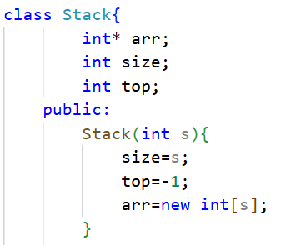
- Modify the code to take user input for all operations.
CODE:
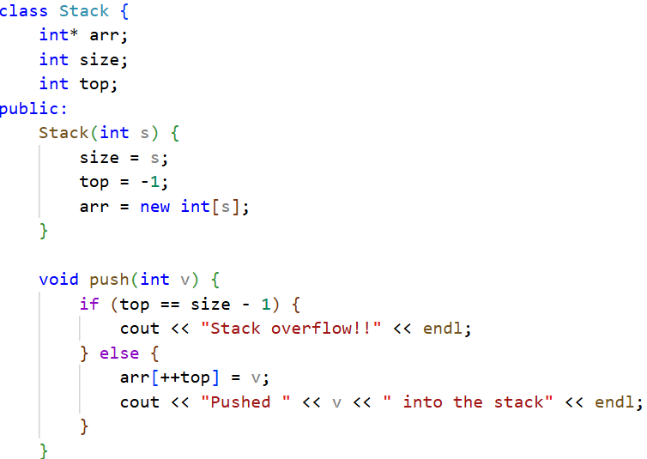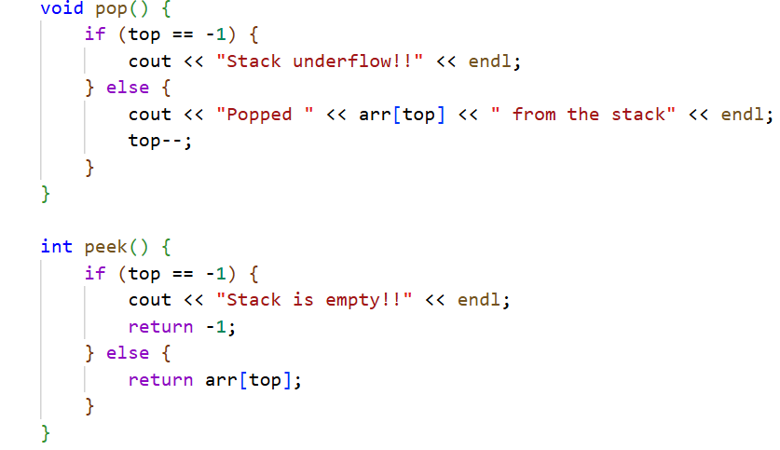
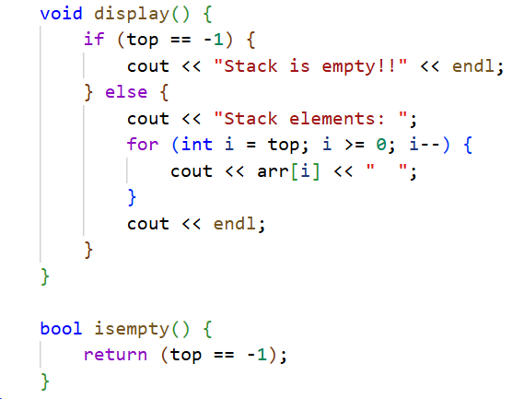
int main() {
int size, choice, value;
cout << "Enter the size of the stack: ";
cin >> size;
Stack s(size);

do {
cout << "\n**************** STACK MENU *************" << endl;
cout << "1. Push" << endl;
cout << "2. Pop" << endl;
cout << "3. Peek (Top Element)" << endl;
cout << "4. Display Stack" << endl;
cout << "5. Check if Empty" << endl;
cout << "6. Exit" << endl;
cout << "Enter your choice: ";
cin >> choice;

switch (choice) {
case 1:
cout<<"-------------------------"<<endl;
cout << "Enter value to push: ";
cin >> value;
s.push(value);
cout<<"-------------------------"<<endl;
break;

case 2:
cout<<"-------------------------"<<endl;
s.pop();
cout<<"-------------------------"<<endl;
break;

case 3:
cout<<"-------------------------"<<endl;
value = s.peek();
if (value != -1)
cout << "Top element is: " << value << endl;
cout<<"-------------------------"<<endl;
break;
case 4:
cout<<"-------------------------"<<endl;
s.display();
cout<<"-------------------------"<<endl;
break;
case 5:
cout<<"-------------------------"<<endl;
if (s.isempty())
cout << "Stack is empty." << endl;
else
cout << "Stack is not empty." << endl;
cout<<"-------------------------"<<endl;
break;
case 6:
cout<<"-------------------------"<<endl;
cout << "Exiting program..." << endl;
break;

default:
cout << "Invalid choice! Try again." << endl;
}
} while (choice != 6);
}

Output:
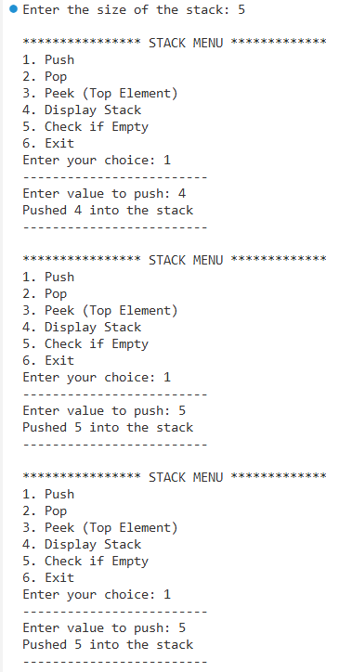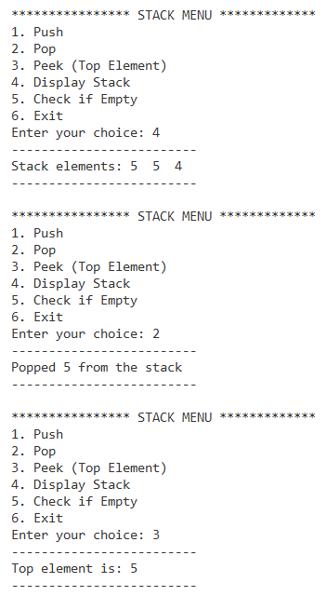
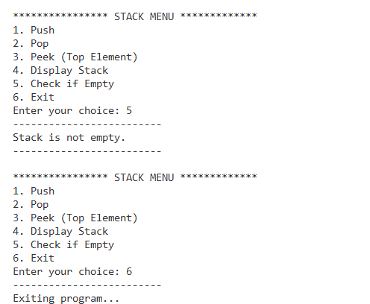

- Implement peek() operation.
CODE:
class Stack{
int* arr;
int size;
int top;
public:
Stack(int s){
size=s;
top=-1;
arr=new int[s];
}
int peek(){
if(top==-1){
cout<<"Stack is empty!!"<<endl;
return 0;
}
else{
return arr[top];
}
}
};

int main()
{
Stack s(6);
s.display();
s.push(9);
s.push(4);
s.push(6);
s.display();
cout << "Top element is: " <<s.peek()<<endl;
}

OUTPUT:
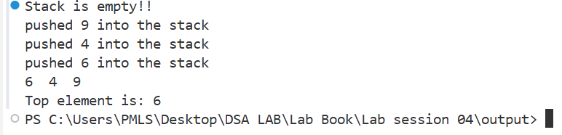
- Check for balanced parentheses in an expression.
CODE:
class Stack{
char* arr;
int size;
int top;
public:
Stack(int s){
size=s;
top=-1;
arr=new char[s];
}
void push(char v) {....}
void pop(){....}
void display(){....}
bool isempty(){....}
char peek() {....}};

bool check(string str) {
Stack s(str.size());
for (int i =0; i < int(str.size()); i++) {
if (str[i] == '('||str[i] == '{'||str[i] == '[') {
s.push(str[i]);
}
else{
if(s.isempty()){
return 0;
}
else if(str[i]==')'){
if(s.peek()!='('){
return 0;
}
else{
s.pop();
}
}

else if(str[i]=='}'){
if(s.peek()!='{'){
return 0;
}
else{
s.pop();
}
}

else if(str[i]==']'){
if(s.peek()!='['){
return 0;
}
else{
s.pop();
}
}
}
}
return s.isempty();
}

int main()
{
string str="((()[{}]{}))";

bool ans=check(str);

if (ans){
cout<<"Parentheses are balanced"<<endl;
}
else{
cout<<"Parentheses are not balanced"<<endl;

}
}

OUTPUT:
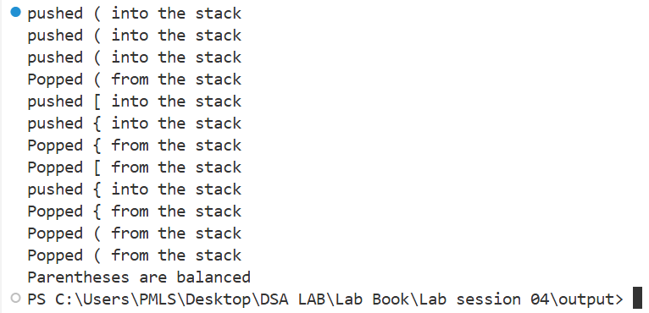

- Display stack elements without modifying them.
CODE:
class Stack{
int* arr;
int size;
int top;
public:
Stack(int s){
size=s;
top=-1;
arr=new int[s];
}
void display(){
if(top==-1){
cout<<"Stack is empty!!"<<endl;
}
else{
for(int i=top;i>=0;i--){
cout << arr[i] << " ";
}
cout<<endl;
}
}
};

int main()
{
Stack s(5);
s.display();
s.push(9);
s.push(4);
s.push(6);
s.display();

}

OUTPUT:
